**Dashboard (Admin)**

7

4

3

2

10

6

1

5

9

8

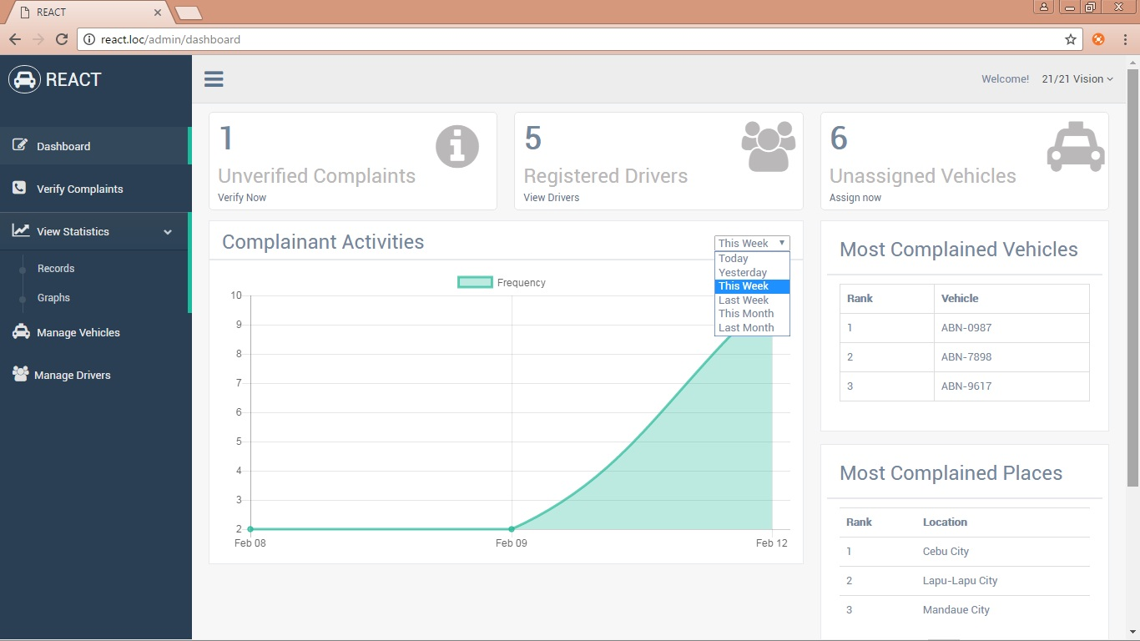

11

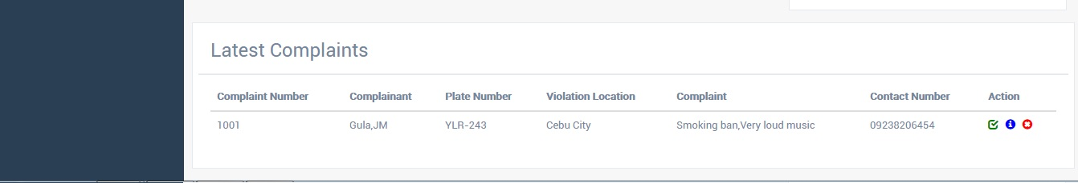

12

14

13

1. Displays verified complaints.
2. Displays statistical records.
3. Display statistical graphs.
4. Displays manage vehicles.
5. Displays manage drivers.
6. Icon View navigation.
7. Displays unverified complaints.
8. Displays registered drivers.
9. Displays unassigned vehicles.
10. Logout button.
11. Displays graphical complaint frequency by month, week and day.
12. Prompt: “Are you sure you want to verify this complaint?”.
13. Directs to complaint details page.
14. Prompt: “Are you sure you want to delete this driver?”.

* If operator clicks **verify complaints button**, it will direct to verify complaints page (23).
* If operator clicks **records button,** it will direct to records page (24).
* If operator clicks **graph button**, it will direct to graph page (25).
* If operator clicks **manage vehicle button,** it will direct to manage vehicle page (26).
* If operator clicks **manage drivers,** it will direct to manage drivers page (27).
* If operator clicks **unverified complaints button**, it will direct to verify complaints on page (23).
* If operator clicks **registered drivers**, it willdirect to managed drivers on page (27).
* If operator clicks **unassigned vehicles**,it willdirect to manage vehicles on page (26).
* If operator clicks **info button**, it will redirect to complaint details page (28).

**Verify Complaints (Admin)**

6

5

2

3

4

1

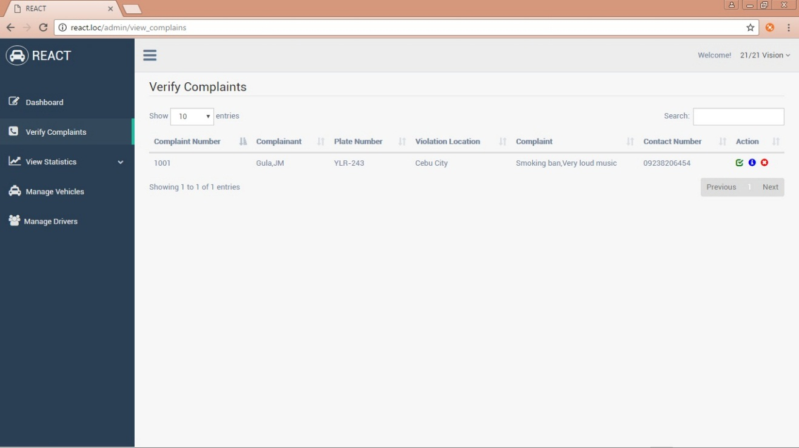

7

1. Displays the number of pages that display.
2. To set the order by ascending or descending.
3. Searches info.
4. Prompt: “Are you sure you want to verify this complaint?”.
5. Displays Info button.
6. Prompt: “Are you sure you want to delete this complaint?”.
7. It proceeds to the next page.
   * If operator clicks **info button,** it will direct to complaint details page (28).

2

**Records (Admin)**

3

4

5

6

1

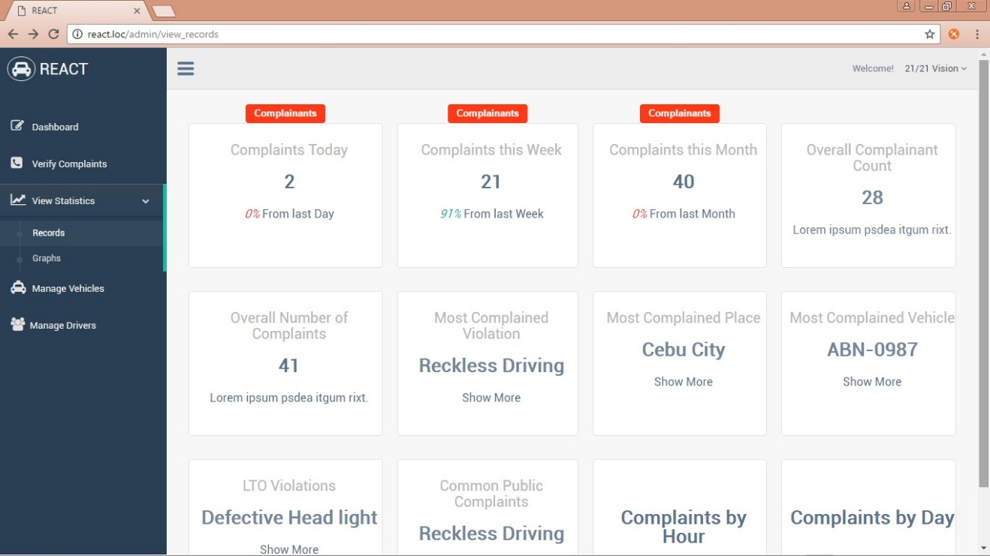

11

13

9

7

8

10

12

14

1. Shows the percentage of complainants for today and yesterday.
2. Displays verified complainants today.
3. Displays verified complaints this week.
4. Shows the percentage of complainants this week and from last week.
5. Shows the percentage of complaints this month and from last month.
6. Displays verified complaints this month.
7. Displays Complaints by LTO Violation and Common Public.
8. Displays Complaints by LTO violation.
9. Displays Complaints List.
10. Displays Complaints by Common Public
11. Displays Complaints by Places.
12. Displays Complaints by Hour.
13. Displays Complaints by Vehicle.
14. Displays Complaints by Day.

**Graph (Admin)**

3

2

4

1

7

6

5

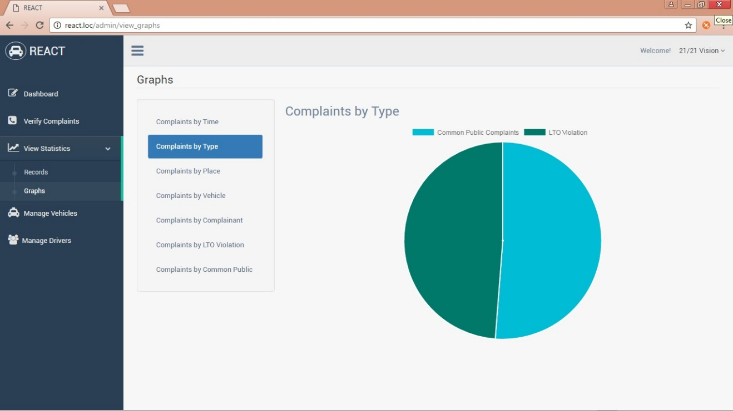

1. Displays complaints by time.
2. Displays complaints by type.
3. Displays complaints by vehicle.
4. Displays complaints by complainant.
5. Displays complaints by LTO violations.
6. Displays complaints by common public.

**Manage Vehicles (Admin)**

3

4

2

1

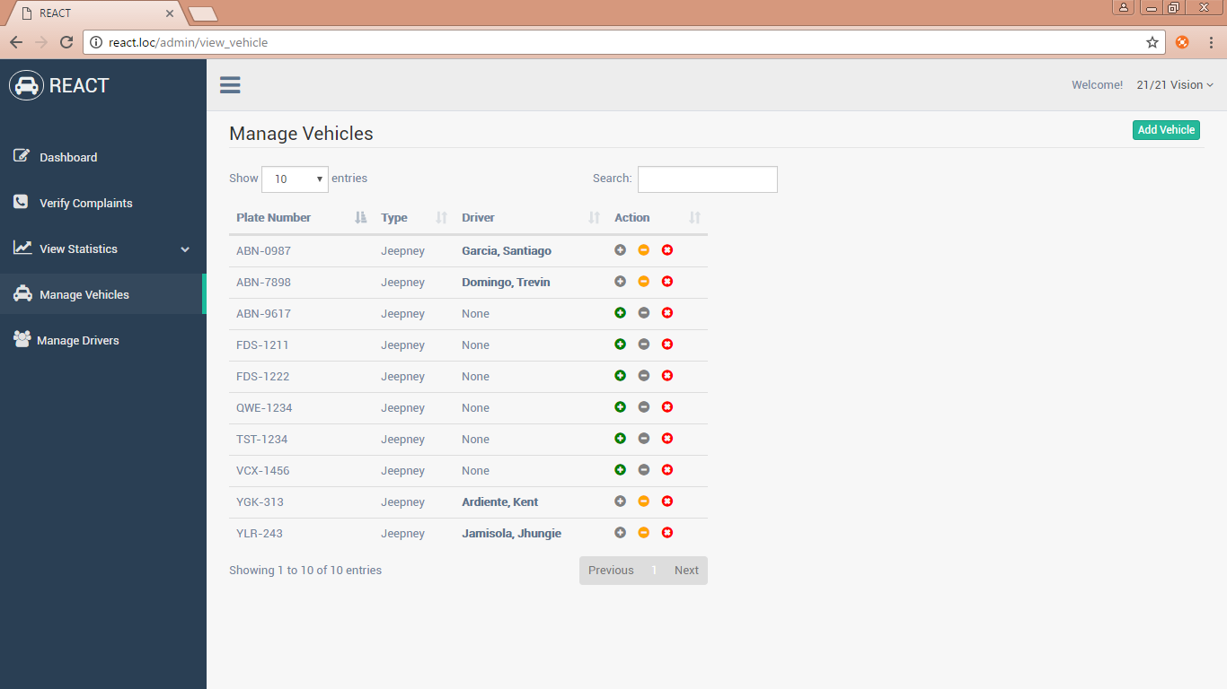

1. Choose driver to assign a vehicle.
2. Unassigned driver to the vehicle and prompt: “Are you sure you want to Unassigned this vehicle?”.
3. Remove vehicle and prompt: “Are you sure you want to delete this vehicle?”.
4. Add vehicle.
   * If operator clicks **assign button**, it will direct to unassigned vehicles page (26).
   * If operator clicks add vehicle button, it will show a modal box on page (30).

**Manage Drivers (Admin)**

4

3

2

1

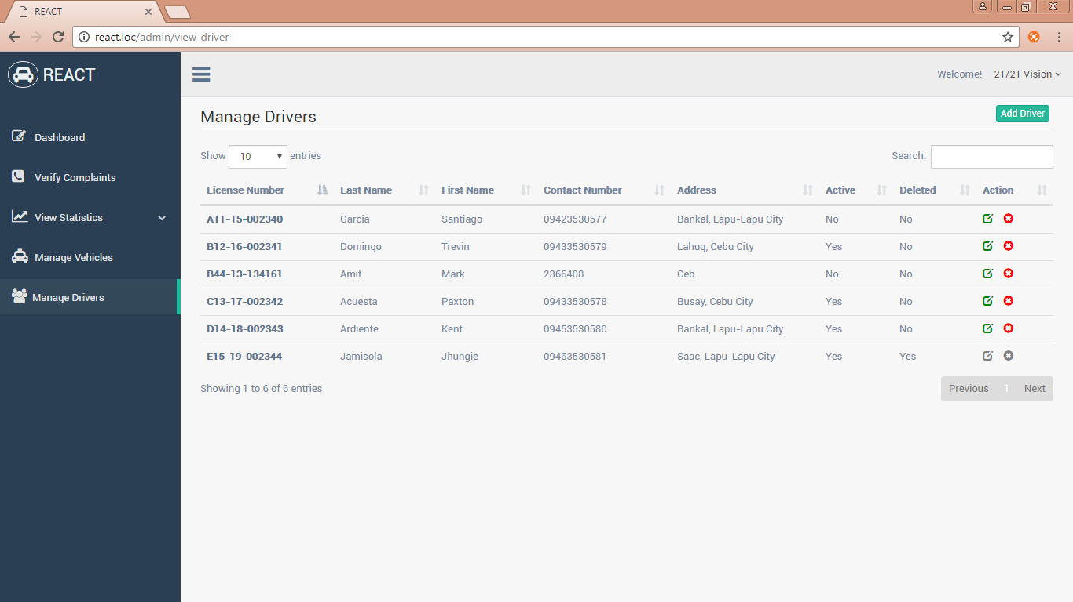

1. Shows the driver’s profile page.
2. It will edit the driver’s info.
3. Remove driver’s info and prompt: “Are you sure you want to delete this driver?”.
4. Directs to add driver page.
   * If operator clicks **edit button**, it will direct to update driver page (31).
   * If operator clicks **add driver button**, it will direct to add driver page (32).

**Complaint Details (Admin)**

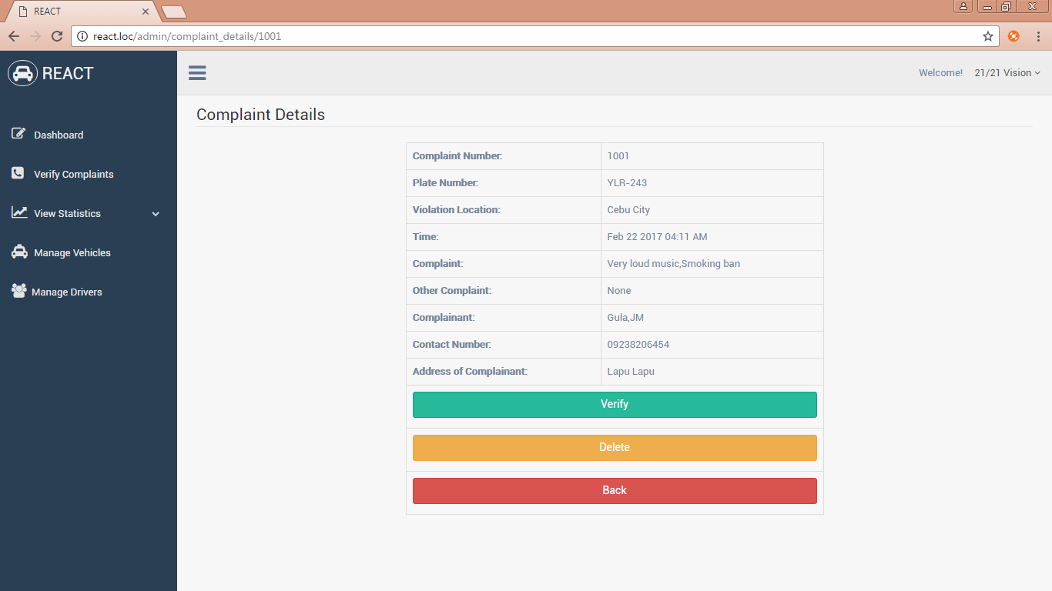

3

2

1

1. Verify complaint and prompt: “Are you sure you want to verify this complaint?”.
2. Delete complaint and prompt: “Are you sure you want to delete this driver?”.
3. It will go to page verify complaints.

**Unassigned Vehicles (Admin)**

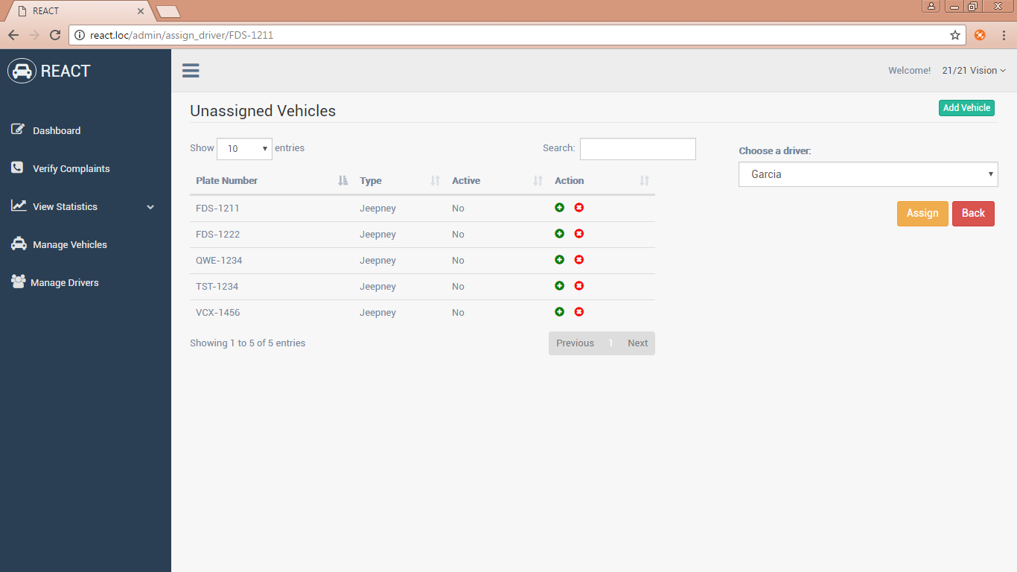

3

2

1

1. It will assign driver.
2. It will go to page manage vehicles page.
3. Chooses to assign driver of the selected vehicle.

**Add Vehicle (Admin)**

4

33

2

1

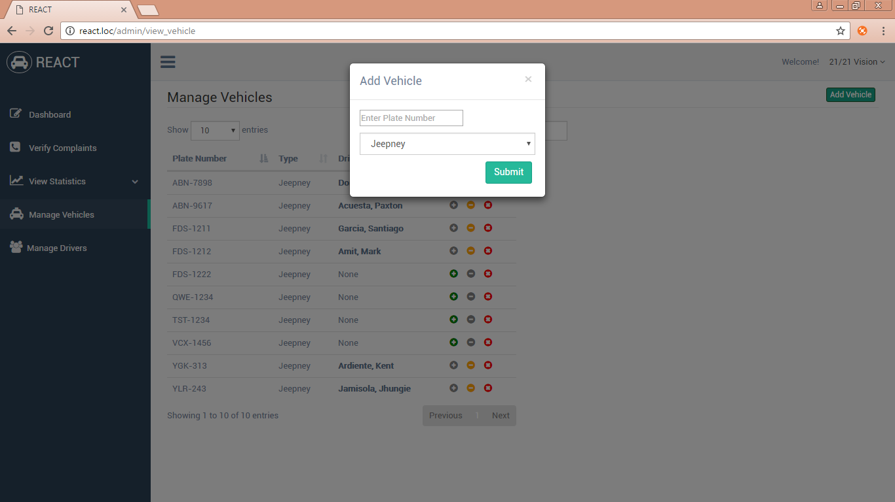

1. Input plate number with standard format.
2. It will close the modal box.
3. It will choose vehicle type.
4. It will add vehicle.
   * If operator input invalid standard format it will display: “Invalid plate number format”.

**Update Driver (Admin)**

43

33

23

13

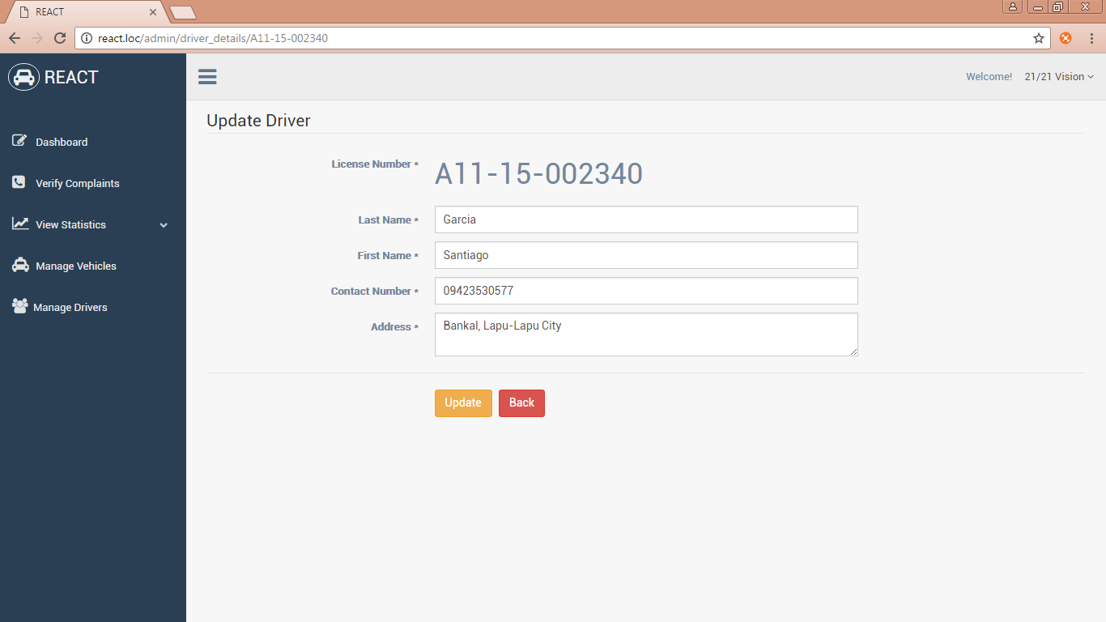

53

63

1. Input last name.
2. Input first name.
3. Input contact number with standard format.
4. Input address.
5. Update the changes of driver’s info
6. Back to page manage drivers.
   * If contact number doesn’t meet of its standards it will display: “The contact number field cannot exceed 11 characters in length.”

**Add Driver (Admin)**

1

2

3

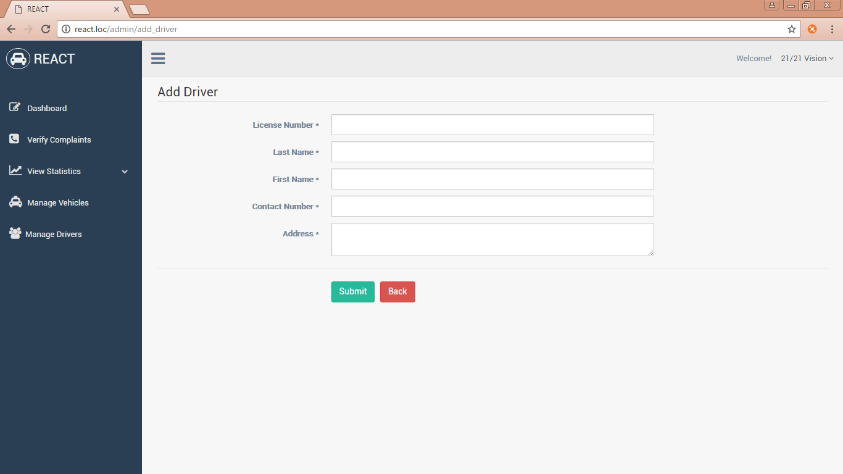

6

4

53

7

1. Input license number with standard format.
2. Input last name.
3. Input first name.
4. Input contact number with standard format.
5. Input address.
6. Add driver.
7. Go back to manage drivers page.
   * If inputted license number doesn’t meet of its standards it will display: “Invalid license format”.
   * If inputted contact number doesn’t meet of its standards it will display: “The contact number field must be at least 7 characters in length.”